**EXPERIMENT 6**

**SOLUTION OF TRANSCENDENTAL EQUATIONS**

**1. Bisection Method**

**CODE**

function [x,e] = mybisect(f,a,b,n)

% a=1

% b=2

% n=13

% function [x,e] = mybisect(f,a,b,n)

% x^3+4*x^2-10

% does n iterations of bisection method

% Inputs: f -- an inline function

% a,b --left and right edges

% n -- no. of iterations

% Outputs: x-- the estimated solution of f(x)

% e -- an upper bound error

%if want to enter value manually

% a=input("enter lower limit: ");

% b=input("enter upper limit: ");

% n=input("enter number of iterations: ");

% f=@(x) (x^3+4*x^2-10);

c = f(a); d= f(b);

if c*d>0.0

error('Function has same sign at both ends');

disp(' x y ')

A=[x y];

disp(A)

end

for i = 1:n

x=(a+b)/2;

y=f(x);

e=(b-a)/2;

if c*y<0

b=x;

end

if d*y<0

a=x;

end

if y*c==0 || y*d==0

break;

end

disp(' x y e ')

A=[x y e];

disp(A)

end

**OUTPUT**

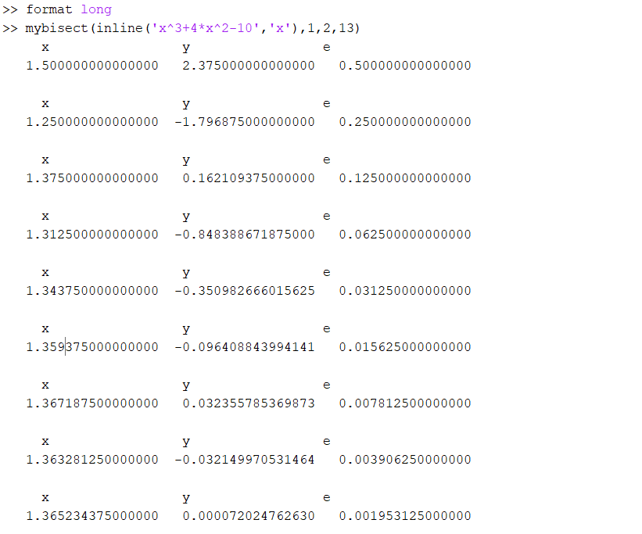

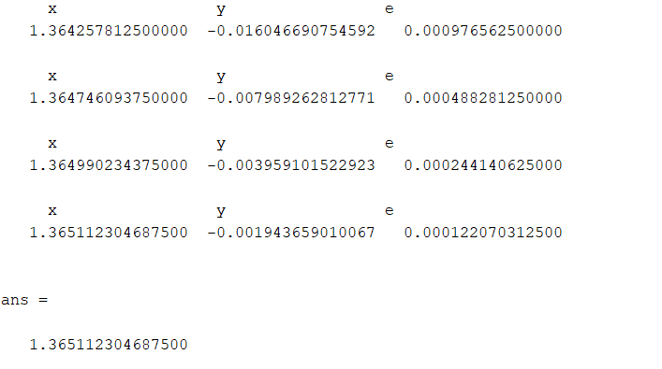

**2.Regular Falsi Method**

**CODE**

function [x,e] = regularfalsi(f,a,b,n)

% a=1

% b=2

% n=20

% function [x,e] = regularfalsi(f,a,b,n)

% does n iterations of bisection method

% Inputs: f -- an inline function

% a,b --left and right edges

% n -- no. of iterations

% Outputs: x-- the estimated solution of f(x)

% e -- an upper bound error

%if want to enter value manually

% a=input("enter lower limit: ");

% b=input("enter upper limit: ");

% n=input("enter number of iterations: ");

% f=@(x) (x^3+4*x^2-10);

c = f(a); d= f(b);

if c*d>0.0

error('Function has same sign at both ends');

disp(' x y ')

A=[x y];

disp(A)

else

for i = 1:n

x=a+((a-b)/(d-c))*c;

y=f(x);

e=(b-a)/2;

if c*y<0

b=x;

end

if d*y<0

a=x;

end

if e==0 %or y*c==0 || y*d==0

break;

end

disp(' x y e ')

A=[x y e];

disp(A)

end

end

**OUTPUT**

